The Academic Progress Report (APR) is a degree audit tool that displays the academic requirements needed to graduate, including those the student has already completed and those not yet completed. The APR replaces the Degree Audit in Degree Works.

This reference gives an overview of the Academic Progress Report (APR).

This reference will cover the following:
Click each heading to jump to content

A. Overview / What is an Academic Progress Report? 2
Why Do Students Have an APR? 2
How Does It Work? 2
Tips on How to Read the APR 3

Introduction / What is an Academic Progress Report?

The Academic Progress Report (APR) is an automated tool that tracks students’ progress towards degree completion. It is designed as a checklist for students. It can help students keep track of their degree requirements and monitor their progress toward completion.

Why Do Students Have an APR?

The Academic Progress Report (APR) keeps track of degree requirements, monitors GPA, and records what courses the student has taken in order to graduate. Additionally, advisors use the APR to guide course selection during registration and the registrar uses the APR to certify for graduation.
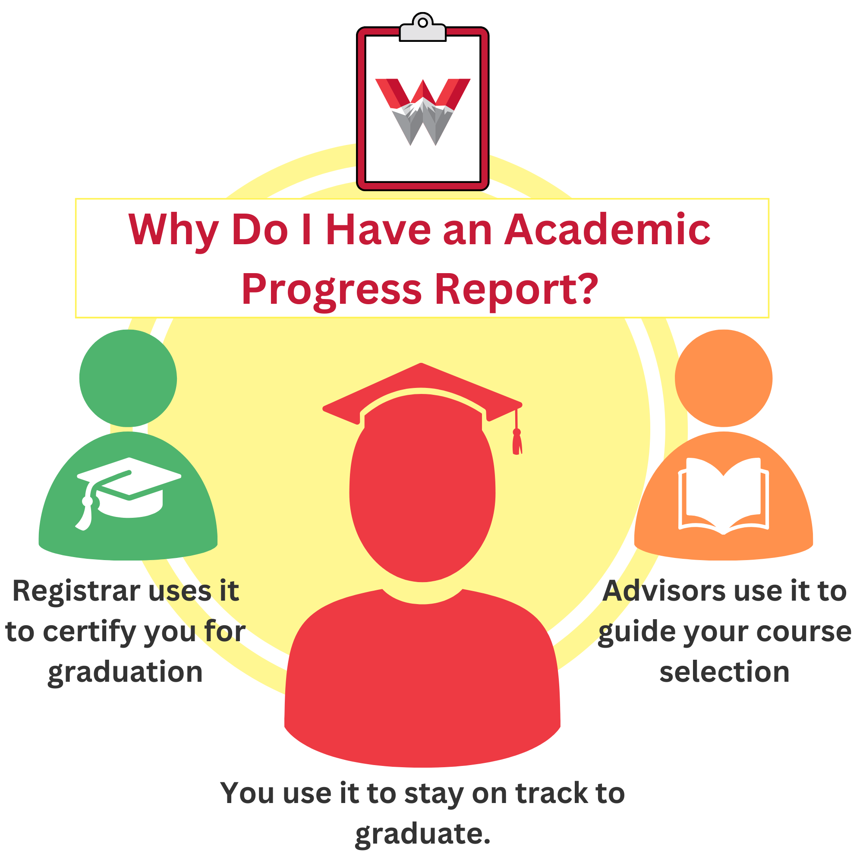

How Does It Work?

Workday student accounts store academic work, including grades, hours and units, transfer units, completed courses, and current courses. Workday also stores academic requirements needed to graduate, including minimum GPA, undergraduate essential skills and general education courses, and the program of study requirements for each major, minor, graduate degree, emphasis, concentration, or certificate.

As students complete coursework, it is arranged alongside the appropriate academic requirements in a way that maximizes the fulfillment of these requirements. This optimized arrangement is the Academic Progress Report.

In other words, the Academic Progress Report shows you exactly which requirements are completed and which are still needed to keep students on track to graduate.

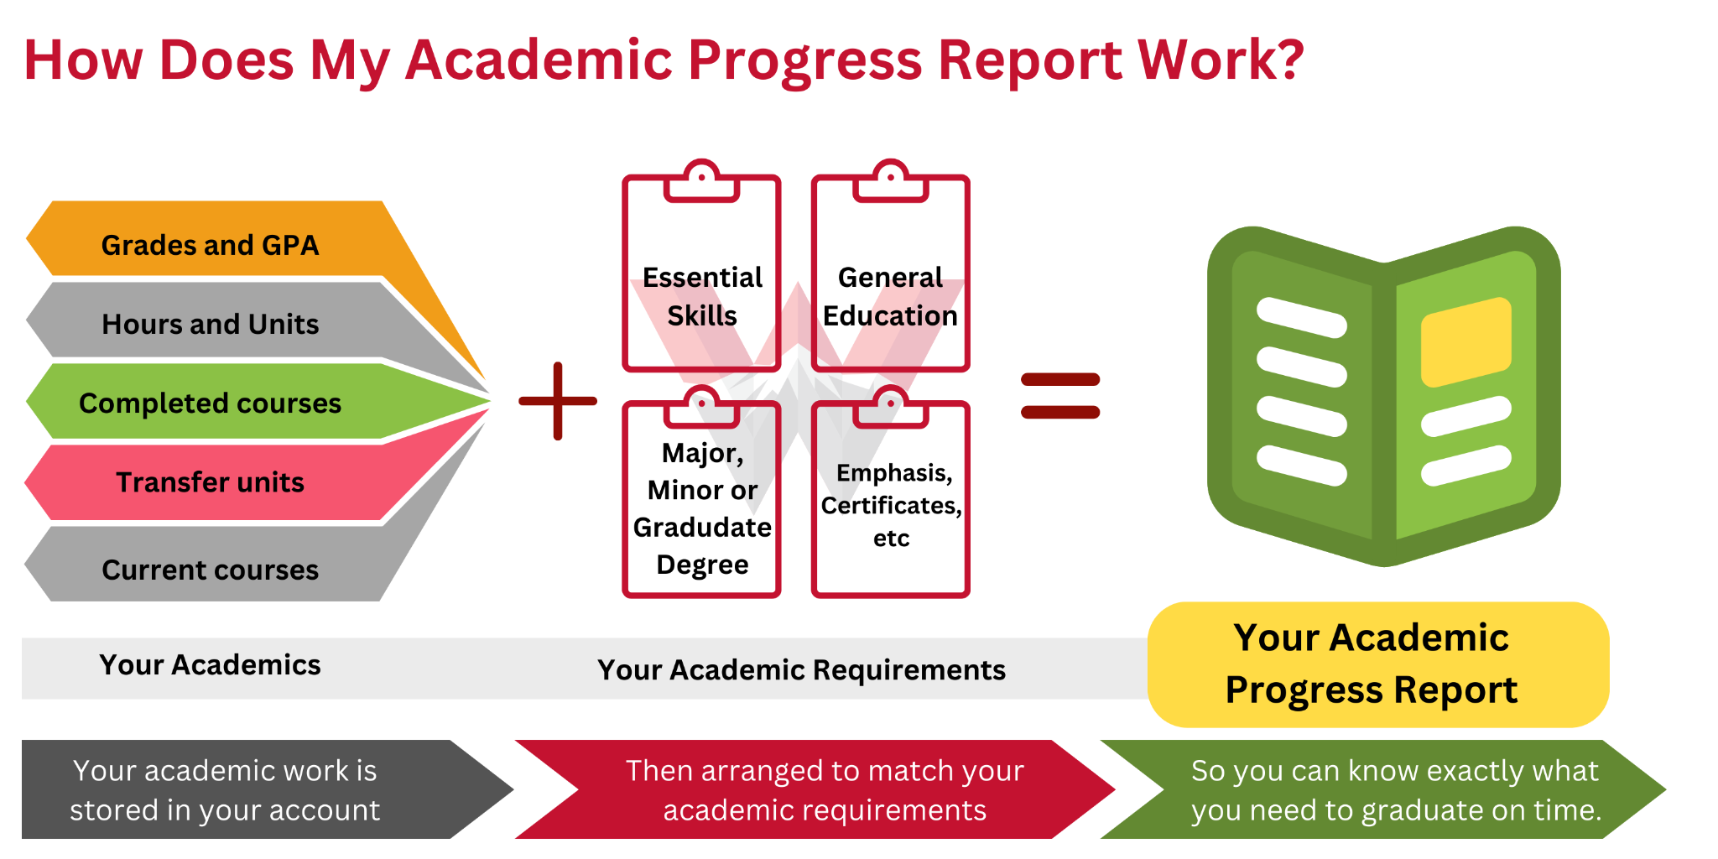

Tips on How to Read the APR
The APR empowers students to make important decisions about which courses they need or do not need to take. Take the time to learn the APR’s 1) organization and 2) functionality (see below).

Organization
- Page Layout
Students’ progress towards overall graduation requirements is displayed at the top of the page. At the bottom, the APR displays progress towards program(s) of study.
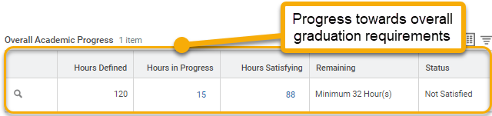
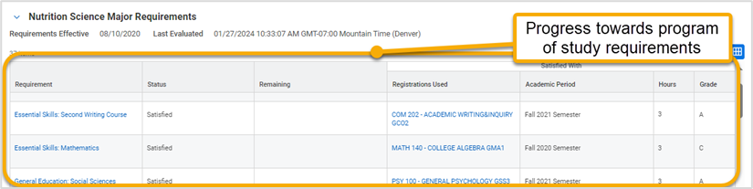
- Requirement Blocks
Each program of study has its own set of requirements. Consequently, each program of study will have its own requirement block. Each requirement block shows the requirements for Essential Skills, General Education, Graduation Requirements followed by that particular program of study.
The blocks default in expanded view. If you have more than one program of study (e.g. double major, or a major and a minor) you can collapse each block to narrow what you can and cannot see.
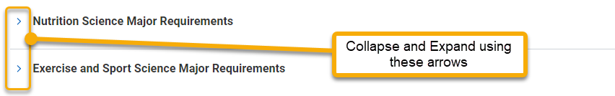
- Reading Requirement Blocks
Each column displays important information about the requirement. Each column can be sorted (arranged in ascending or descending order) or filtered (display only certain values) to narrow what you can and cannot see.
To ensure you see all requirements, select “View All” at the bottom of the block.
To view requirement details, such as minimum grade required or acceptable courses, hover over the requirement title and click the related actions button .
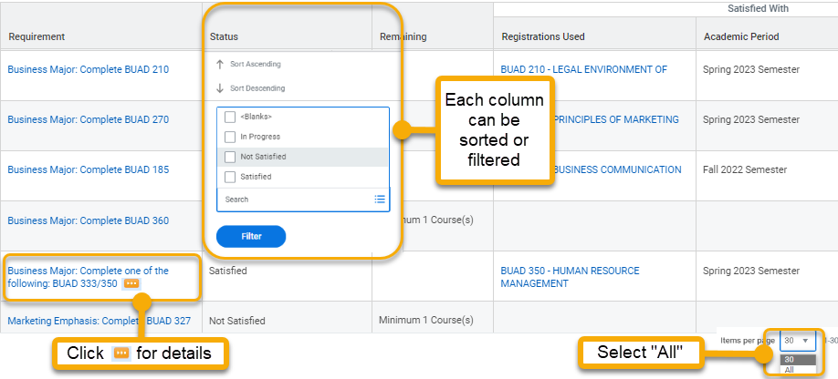

Functionality
- Fulfilling Requirements
As students complete courses, their account will automatically sort and assign work to fulfill the maximum number of academic requirements. Although these assignments may change slightly as additional classes are completed, the “Satisfied” status is permanent and will not change.
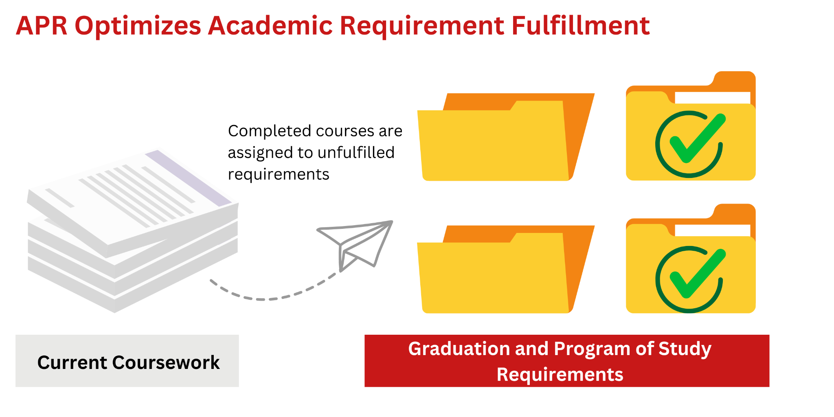
- Satisfying requirements
The APR uses only completed coursework to set a requirement to “Satisfied”. Courses that are not yet complete will render the status “In Progress”. Students must complete the course with the minimum required grade in order to successfully earn hours towards the requirement. Once the minimum required grade is posted, the APR will update within 24 hours changing the requirement status to “Satisfied”.

